James Liu

CS 4495, Computer Vision

Fall 2014

Problem Set 2

**Problem Set 2, Question 1, Part A, Image 1: Left to Right**



**Problem Set 2, Question 1, Part A, Image 2: Right to Left**



Note: I had to apply an absolute value to this one to get anything to show, because the disparities in the square were negative.

**Problem Set 2, Question 1, Part A, Image 3: Left to Right Plot**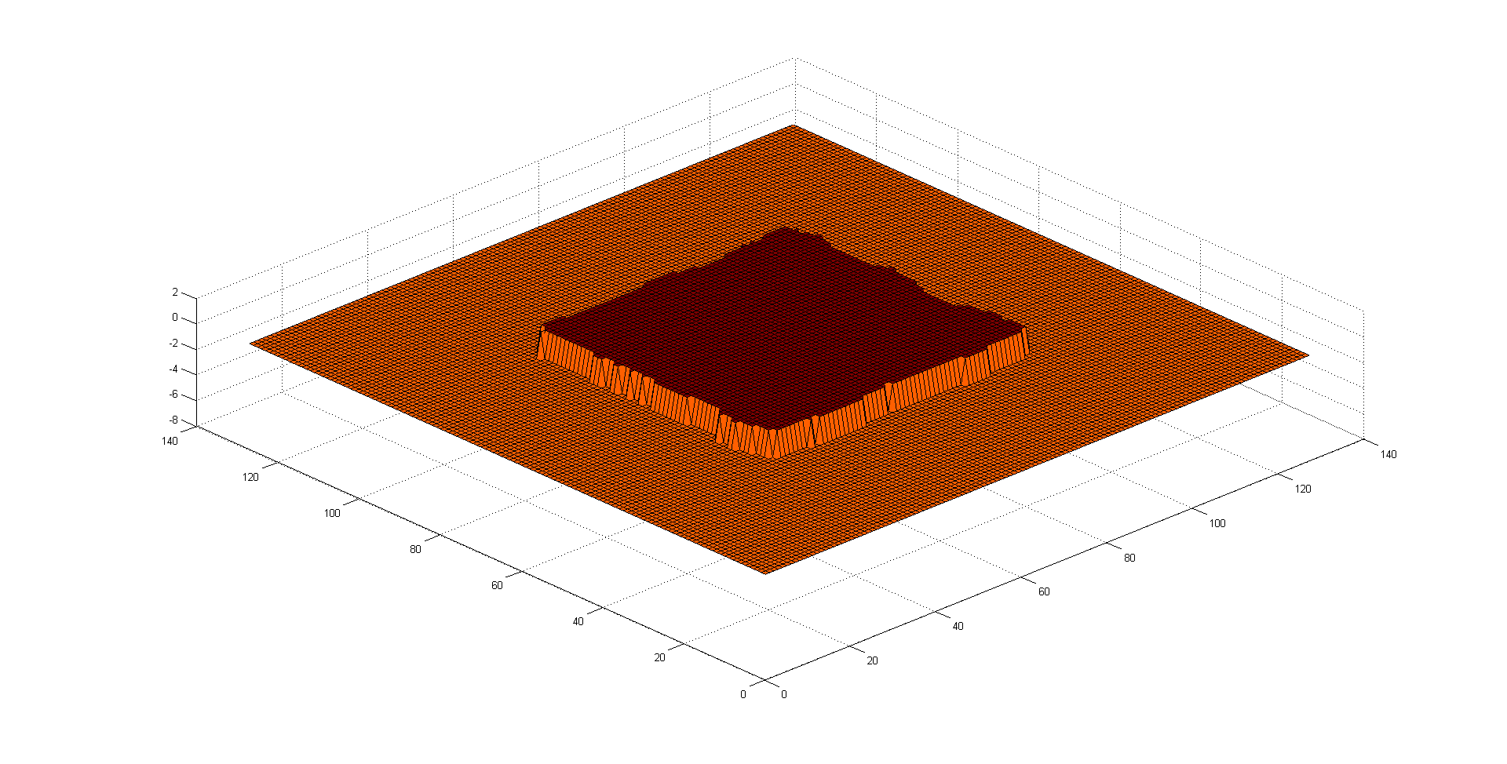

**Problem Set 2, Question 1, Part A, Image 4: Right to Left Plot**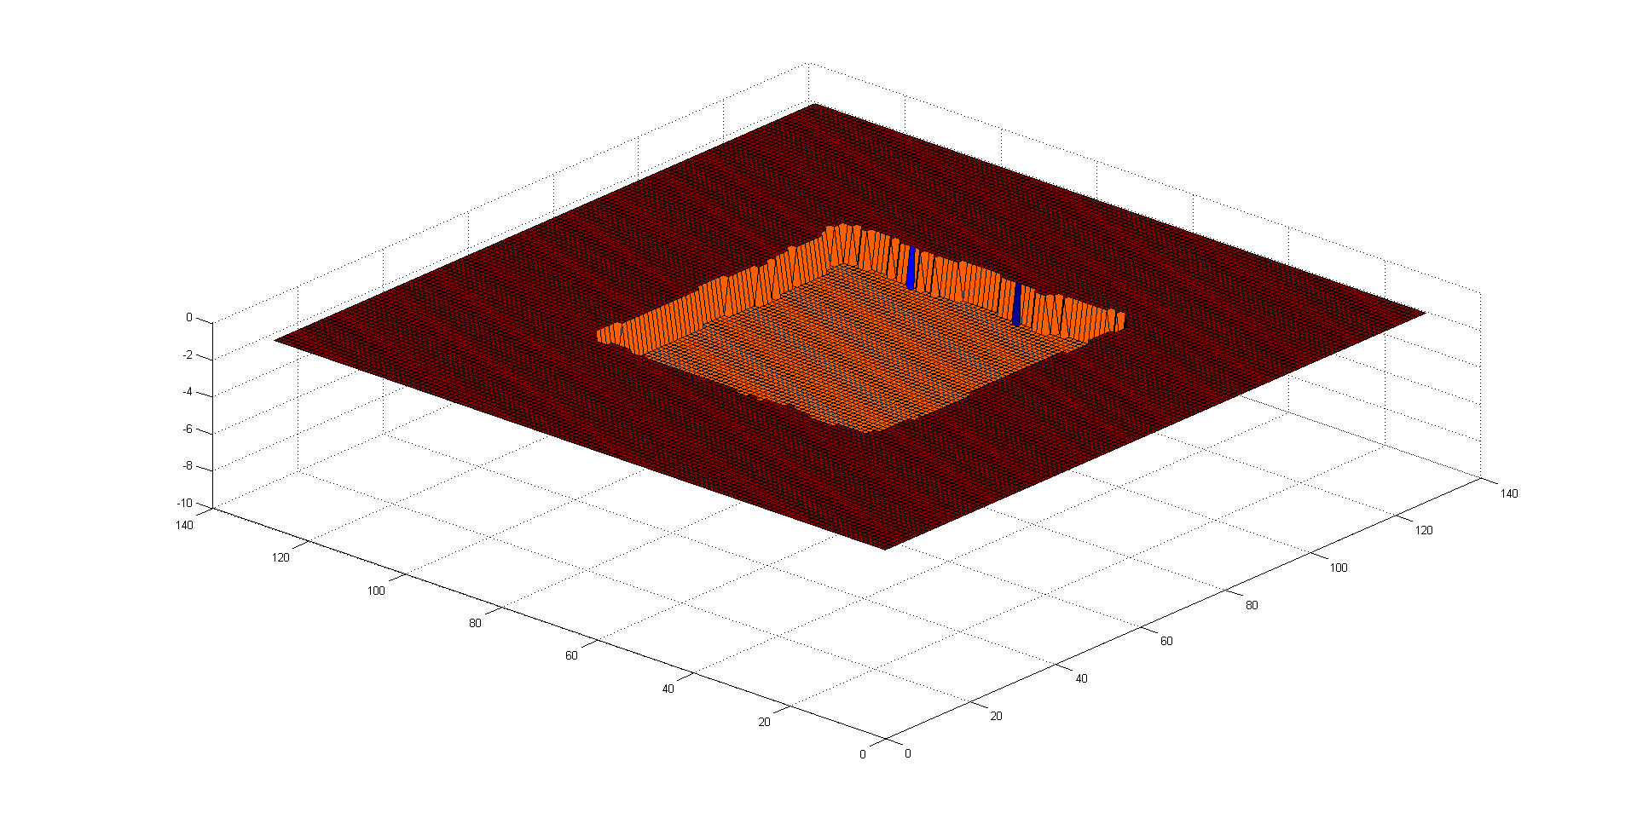

**Problem Set 2, Question 2, Part A, Image 1: Left to Right**

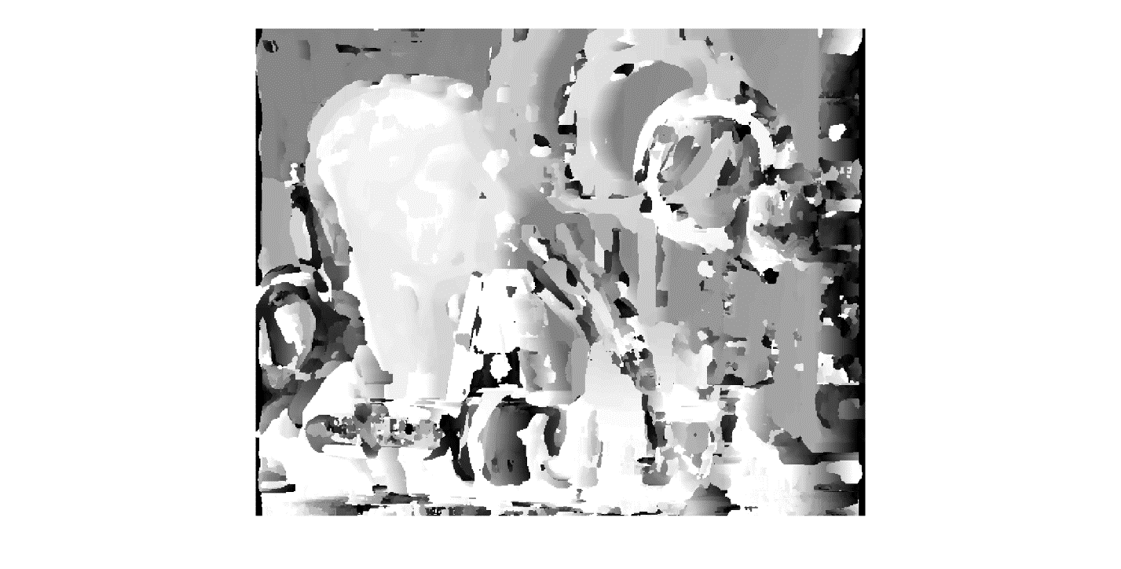

**Problem Set 2, Question 2, Part A, Image 2: Right to Left**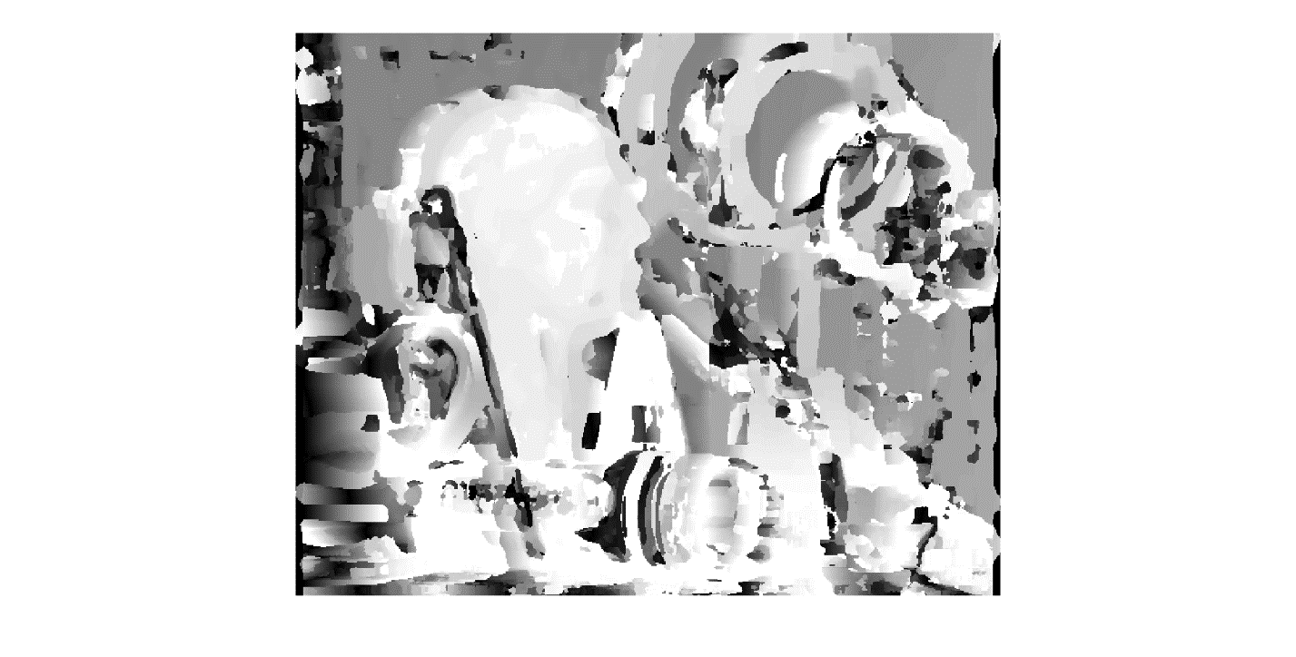

**Problem Set 2, Question 2, Part B**

There’s a very noticeable difference between the left to right and right to left disparity images. The paint brush in the foreground creates occluded pixels in the right to left disparity image, which is why there is a dark portion in front of the mannequin head. There is a notable difference between the ground truth and the disparity images produced by the sum of squared differences algorithm. The fact that the passing disparity check took into account pixels outside of the image (which I defaulted to 0), there are streaks in both disparity images near the edges where the algorithm started matching with the padded area of the image. There are also a number of mismatched patches that can be attributed to bad choice of window size or noise.

**Problem Set 2, Question 3, Part A, Image 1: Left to Right**

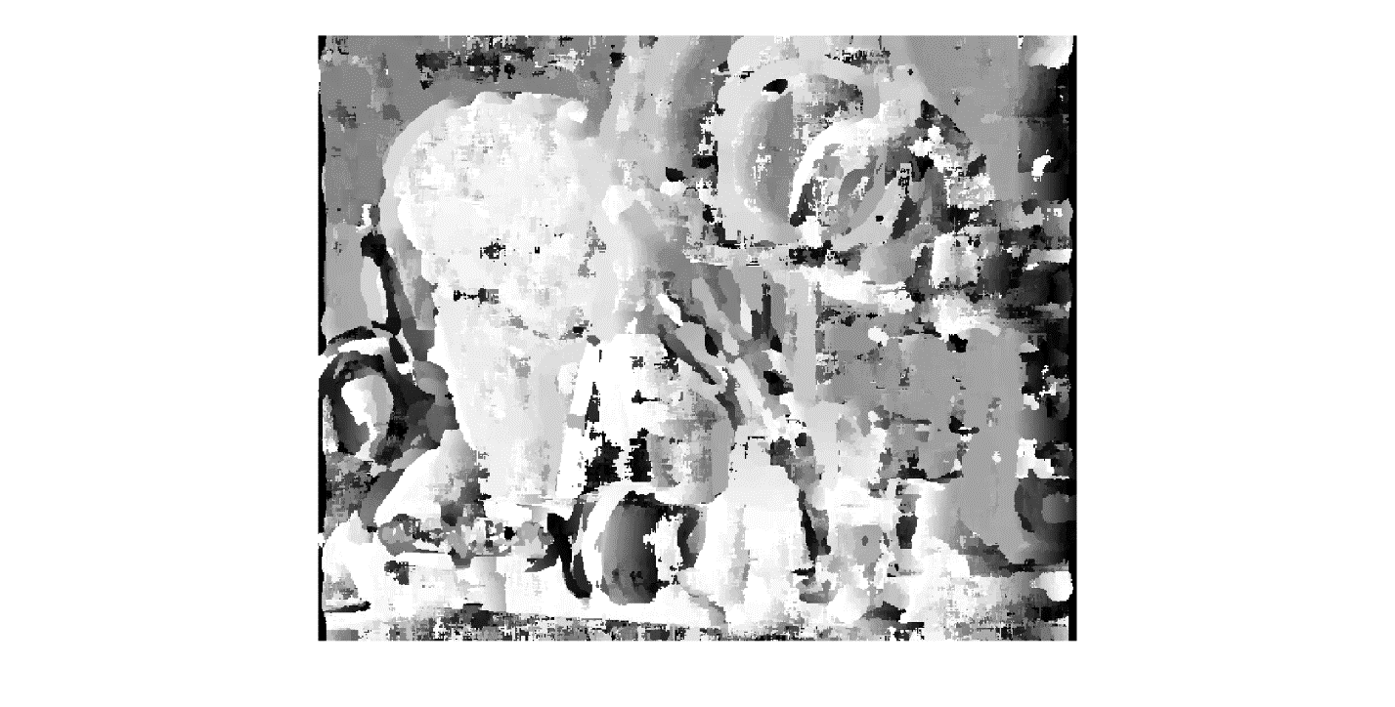

**Problem Set 2, Question 3, Part A, Image 2: Right to Left**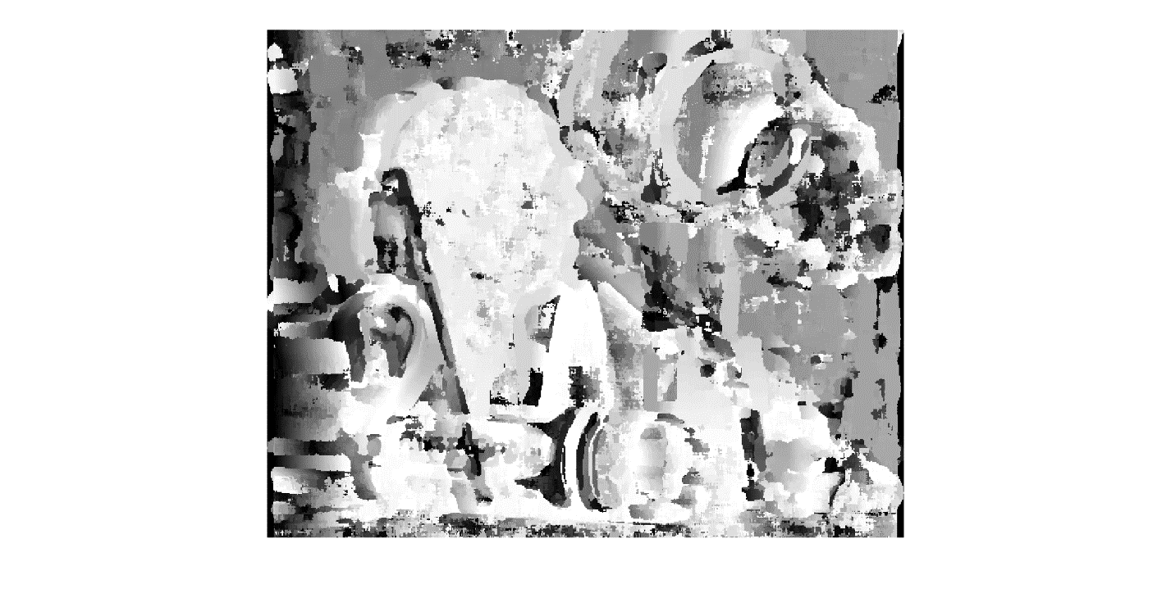

It’s fairly obvious that adding even slight noise can perturb the resultant disparity images. With zero-mean Gaussian noise with a variance of 0.005, the edges of the individual objects become distorted, and some objects aren’t even recognizable, like the rings on the right side.

**Problem Set 2, Question 3, Part B, Image 1**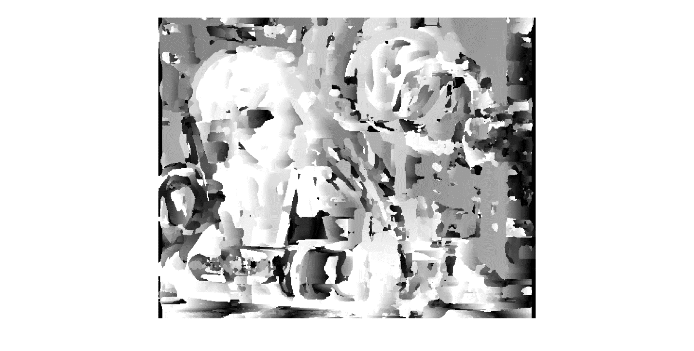

**Problem Set 2, Question 3, Part B, Image 2**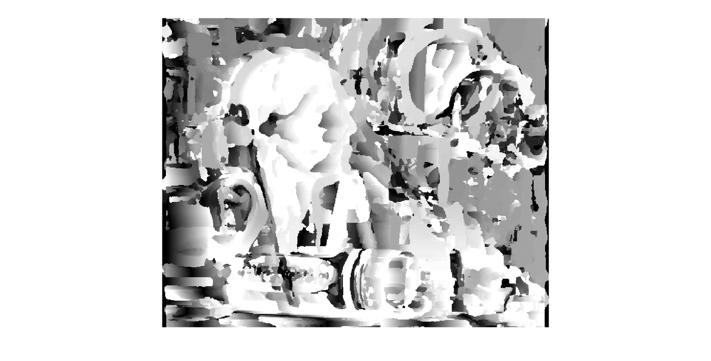

Altering the intensity also slightly perturbed the resultant disparity images. The number of mismatched patches increased as the altered intensity caused previous matches to shift along the intensity gradient. The streaks also became more prominent, and small details like the facial features on the mannequin head became overly pronounced and exaggerated.

**Problem Set 2, Question 4, Part A, Image 1: Left to Right**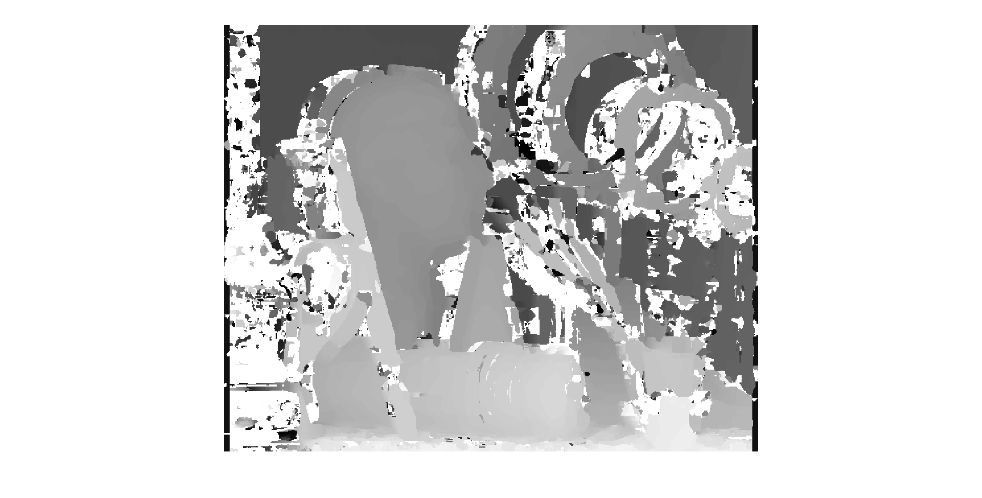

**Problem Set 2, Question 4, Part A, Image 2: Right to Left**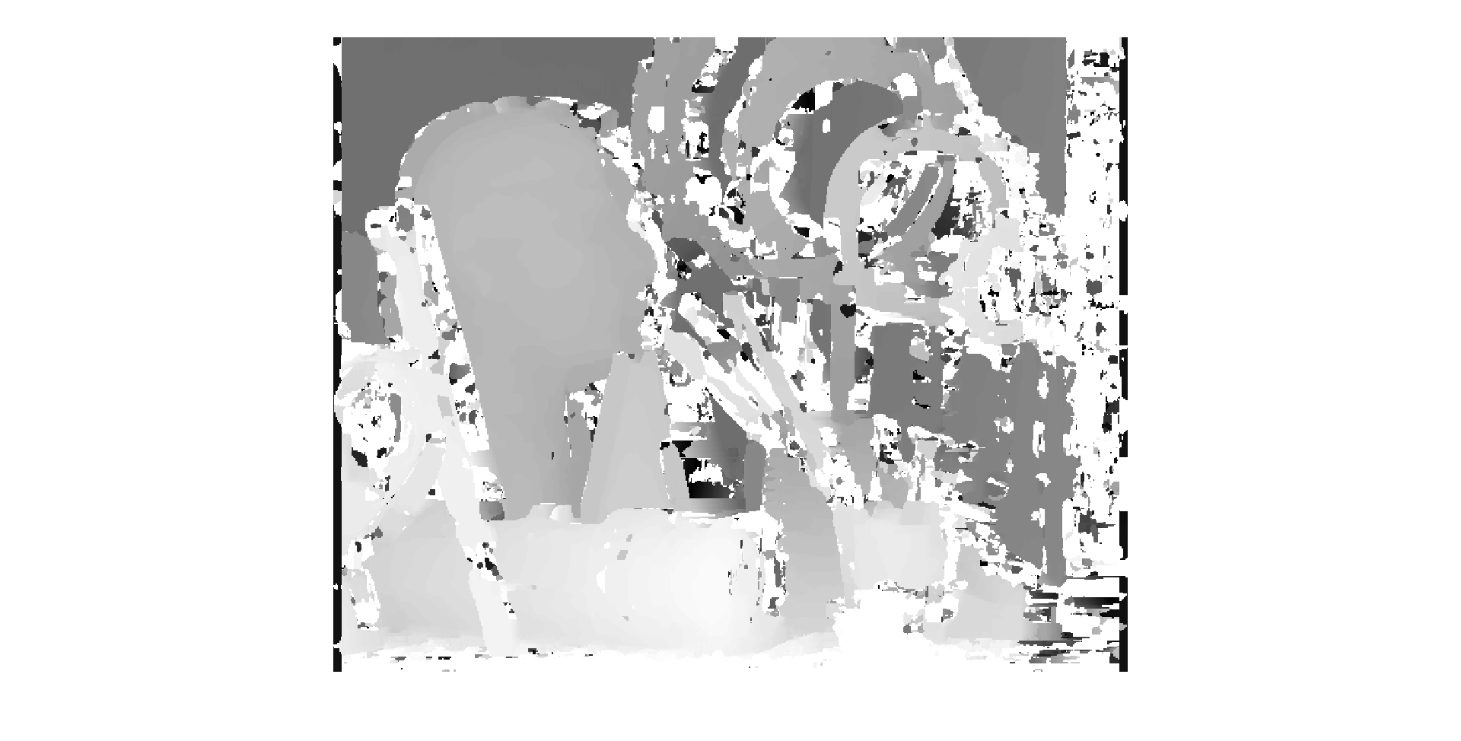

Other than the strong noise in areas of non-objects that is likely due slight errors in my implementation, the main objects and background are far closer to the ground truth than the results of SSD were. It even properly captured the disparity gradient along various objects like the large crayon, the brush, and the manniquen head, unlike the SSD results. The relative disparity values differences, how the manniquen head should have lower disparity values compared to the brush or crayon due to being farther away, is also present, unlike the SSD results.

**Problem Set 2, Question 4, Part B, Image 1: Left to Right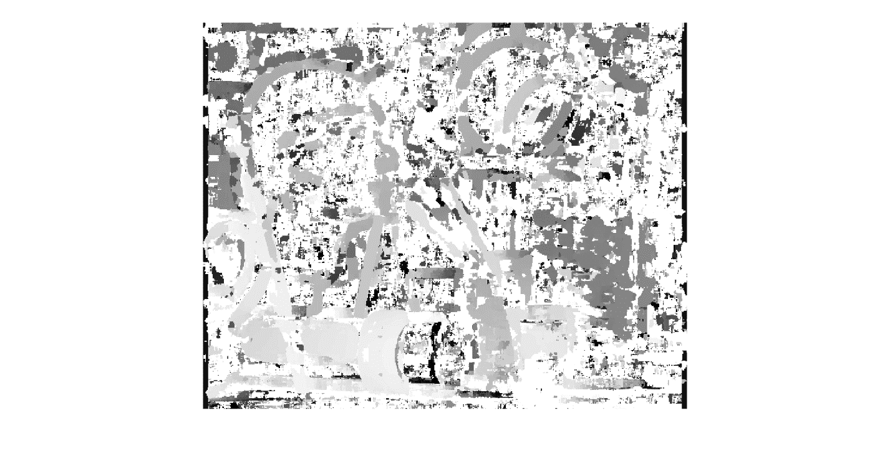 Problem Set 2, Question 4, Part B, Image 2: Right to Left**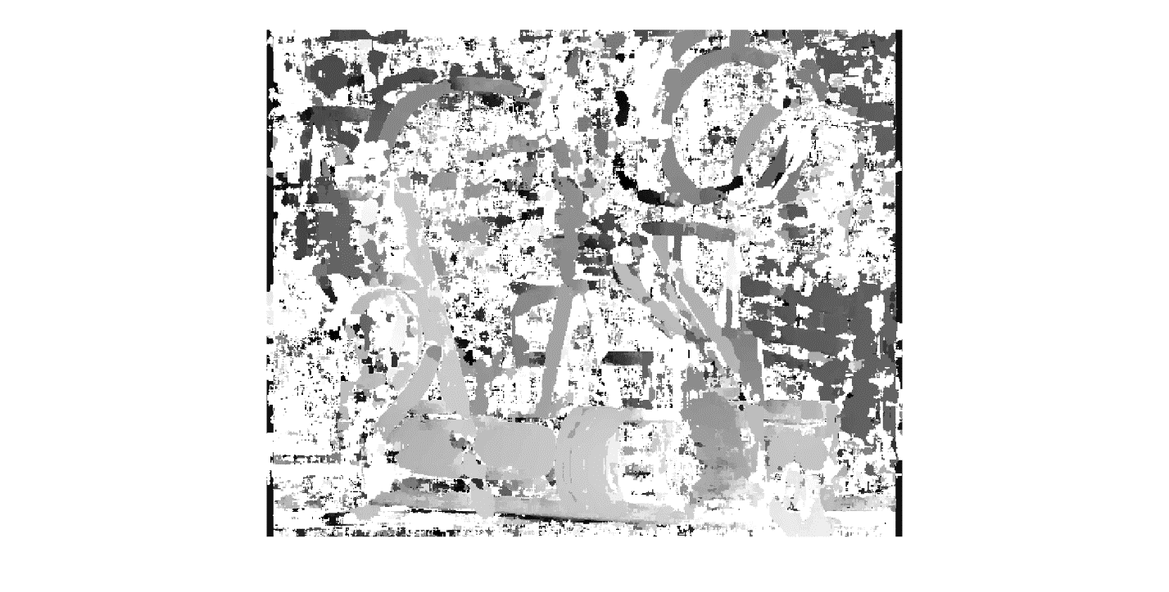

Compared to the noise-less results, these are notably worse. However, it seems that the noise seen these images is the same noise that came from my implementation or window size choice than anything else. This normally wouldn’t be much of an issue, as the normalized cross correlation would normalize any significant noise in the either the template or the target images, and would be less affected by the noise than SSD is.

**Problem Set 2, Question 4, Part B, Image 3: Left to Right**

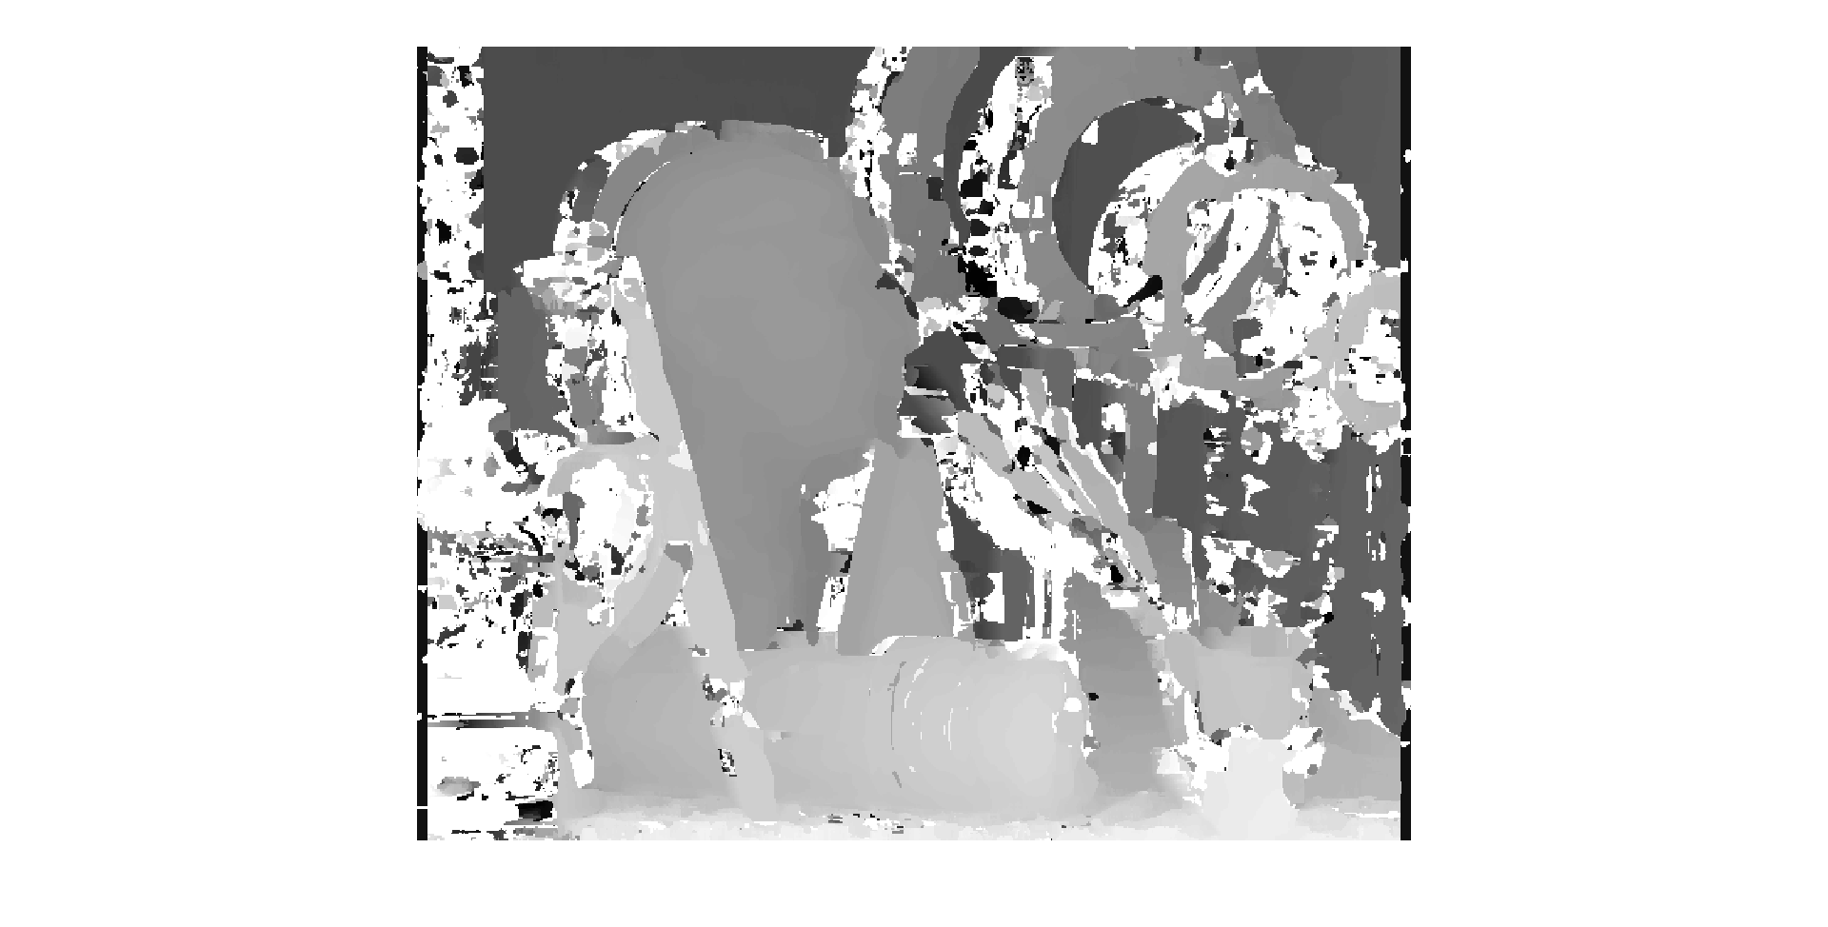 **Problem Set 2, Question 4, Part B, Image 4: Right to Left** 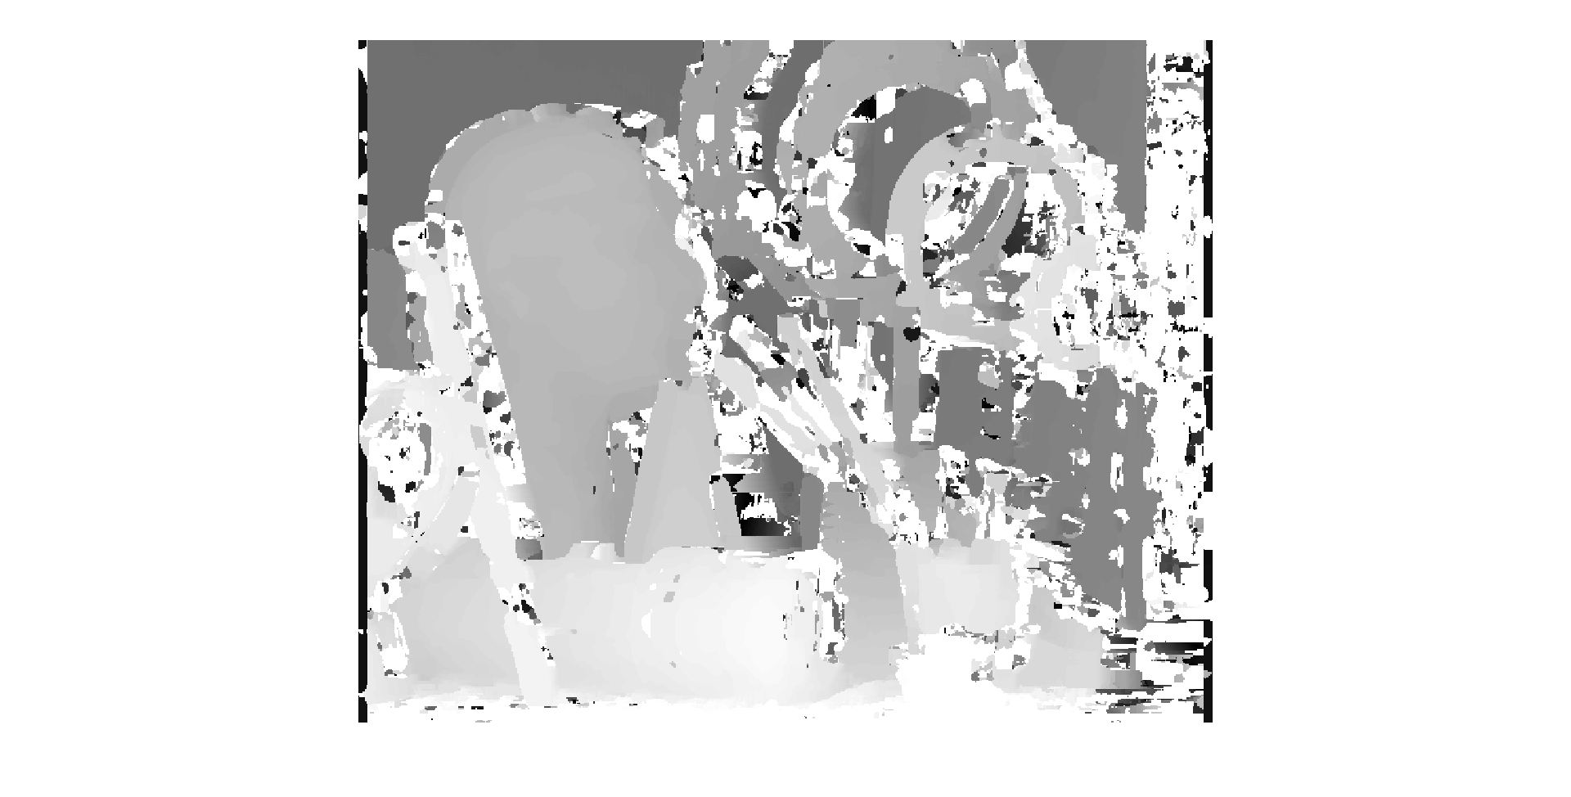

Compared to the SSD and the non-contrast enhanced version, it isn’t much worse. The white noise is notably higher, but not to the level as the Gaussian noise results. There aren’t any large blotches that were mismatched, unlike the SSD results.